Roto Spore Sampler
Operating Instructions

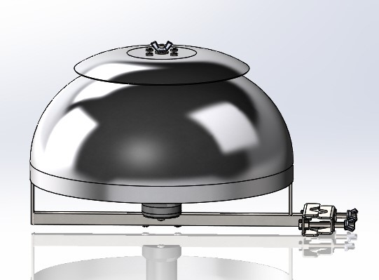


Roto Spore Sampler Without Rain shield
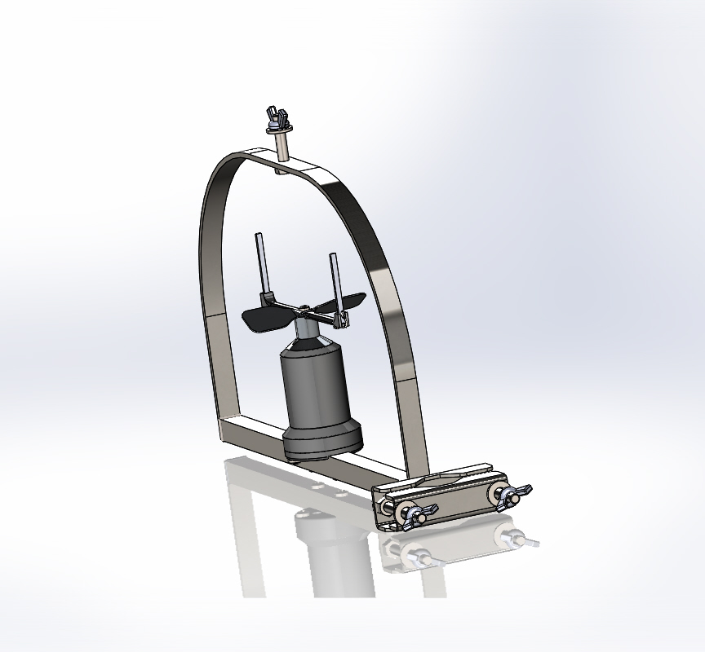
Showing correct Fitting of sampling rods
Roto Spore Sampler
Operating Instructions: V1
Unpacking Unit
Please take care to unpack carefully making sure that no parts are left in the packaging materials.
Parts included
1 Roto Spore Sampler
1 Rain Shield
1 Control Box

Assembly and levelling
Once the unit is fully unpacked.
The sampler can be attached to an appropriate support Pole ( 25mm Dia min – 50mm Dia Max)
When you have the sampler mounted securely the sampling rods can be inserted into the sampler.
This is done by sliding the rods into each end of the sampling arm of the sampler the rods fit at the end of the rotating arm secured in place by the spring clamp.
The leading edge of the sampling rod is coated with Vaseline. The rotating arm of the sampler rotates clockwise when viewed from above.

Power requirements
The unit is 12 volt DC powered, the trap will draw up to 0.1amps when running.
Then trap is fully installed ready for setting up, please use the menu commands to set up the trap and load sampling rods.
Please ensure battery clips are attached correctly to the battery
Red to the positive terminal +
Black to the negative terminal –

Battery requirements
The unit runs off a 12v battery. The best battery to use is a cyclic or leisure battery. But a standard lead acid will do. A battery with 20 Amh will run the unit for 1 week continuously.

Sampling Rods
The sampling rods are reusable but should you need replacements these can be purchased from Agri Samplers Ltd

Menu commands List in order:
Power on screen will show unit name and software version. This will change to the home screen after a few seconds.
Home screen will show status of trap (Sample Stop, or Sampling, or Wait to sample) and the time.

Menu displays are:
1 Run Enable: Used to start and stop the unit when in sampling mode.
2 Clock Set: Used to set the time on the trap.
3 Start Delay: Used to set how many days the trap waits before starts sampling.
4 Sample Start: Used to set sampling start time.
5 Sample Finish: Used to set sampling finish time.
6 Cycle Times: Used to set an on and off time during the sampling period
7 Manual Fan: Used to start and stop sampling manually.

Home Screen
Shows status of trap
Sample stop Trap has been turned off using the “Run Enabled” function.
Wait To Sample Trap is waiting to start sampling, this can be because a delay has been set or is outside a sampling period.
Sampling: trap is sampling and the pot number of pot it is using.
Cycling shows when the trap has cycling times set up.
Time shows current time set on the trap.

1 Run Enable:
Used to start and stop the unit when in sampling mode. This can be used to halt a sampling program to allow the user to change vials.
RUN ENABLE?
OK=YES MENU=NEXT

press OK to enter menu
RUN ENABLE: YES
USE +/- THEN OK

press + to enable or press – to disable run
then OK to exit

2 Clock Set:
Used to set the time on the trap.
SET CLOCK
OK=SET MENU=NEXT

Press OK to enter menu
CLOCK HRS 12:00
USE +/- THEN OK

Use +/- to adjust clock hours ok to move on to set minutes
CLOCK MIN 12:00
USE +/- THEN OK

Use +/- to adjust clock minutes
Then use OK to exit

3 Start Delay:
Used to set how many days the trap waits before starts sampling.
SET DELAY
OK=SET MENU=NEXT

Press OK to enter menu
START DELAY ? :0
USE +/- THEN OK

Use +/- to adjust delay required

Each delay set will stop the sampler sampling for 24 hours. So each time the clock goes past 12pm (midnight) it will remove one from this number then when it is 0 it will start sampling at the next sampling time set.

4 Sample Start:
Used to set sampling start time.
SAMPLE START?
OK=SET MENU=NEXT

Press OK to enter menu
CLOCK HRS 8:00
USE +/- THEN OK

Use +/- to adjust clock hours ok to move on to set minutes
CLOCK MIN 8:00
USE +/- THEN OK

Use +/- to adjust clock minutes ok to exit to sample finish

5 Sample Finish:
Used to set sampling finish time.
SAMPLE FINISH?
OK=SET MENU=NEXT

Press OK to enter menu
CLOCK HRS 9:00
USE +/- THEN OK

Use +/- to adjust clock hours ok to move on to set minutes
CLOCK MIN 9:00
USE +/- THEN OK

Use +/- to adjust clock minutes
Then use OK to exit

6 Cycle Times:
Used to set an on and off time during the sampling period. This will make the trap turn on and off repeatedly during a sampling period, all samples during this period will be into the same vial.
CYCLE TIMES?
OK=SET MENU=NEXT

Press OK to enter menu
MINS ON: 0
USE +/- THEN OK

Use +/- to adjust
MINS OFF: 0
USE +/- THEN OK

Use +/- to adjust
Then use OK to exit
7 Manual Sample:
Used to start and stop sampling manually.
MANUAL FAN?
OK=SET MENU=NEXT

Press OK to enter menu
MANUAL FAN?
USE +/- THEN OK

Use + to turn on the sampler
Use – to turn off the sampler
Then use OK to exit

